* **A new pub near the main road with an old English architecture but modern too.**
* **10 minutes from Rheindahlen and 5 minutes from Hardt by car.**
* **With a bus station near the pub and extra buses for the night.**
* **Private big parking for the clients.**

**Big free inauguration with cocktail, beer, open air, music, tipical English sports and more….**

**A NEW INAUGURATION OF A BRITISH PUB**

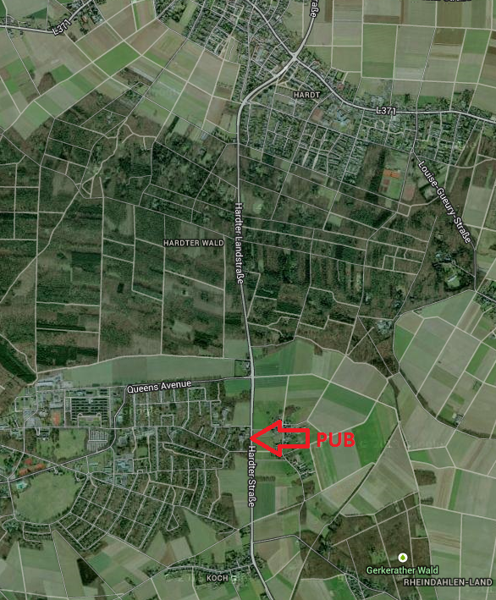

**EVERYONE IS WELCOME!**